
K4 CSF3133 REKA BENTUK ANTARA MUKA BERASASKAN WEB
LAB REPORT 5
SEMESTER 3

PREPARED FOR: ASSOC. PROF. TS. DR. WAN NURAL JAWAHIR
LAB ASSISTANT: MISS WAN FATIN

PREPARED BY: AKMA ASYIFA BINTI ZULKARNAIE
NO. MATRIC: S75186
SUBMISSION DATE: 19 November 2025

Lab 5 – Cascading Style Sheets (CSS)
5.3 Inline CSS
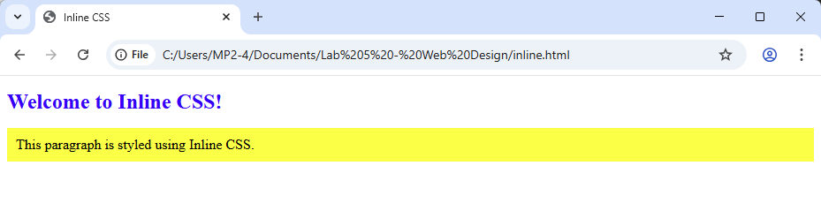
5.4 Internal CSS
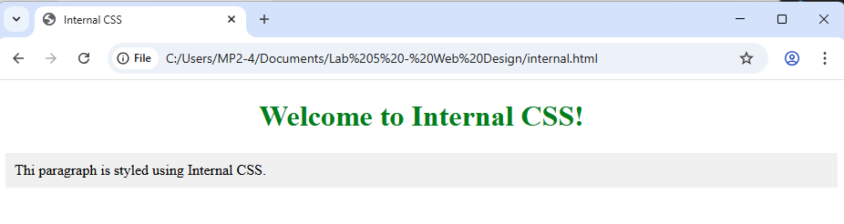
5.5 External CSS
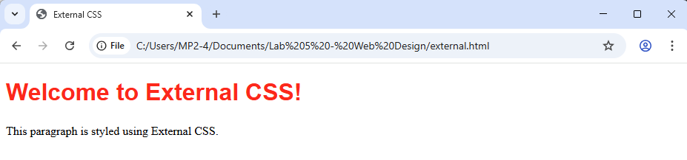
5.6 Link to file CSS (from another browser)
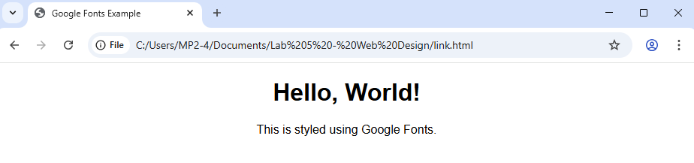

5.7 CSS Backgrounds
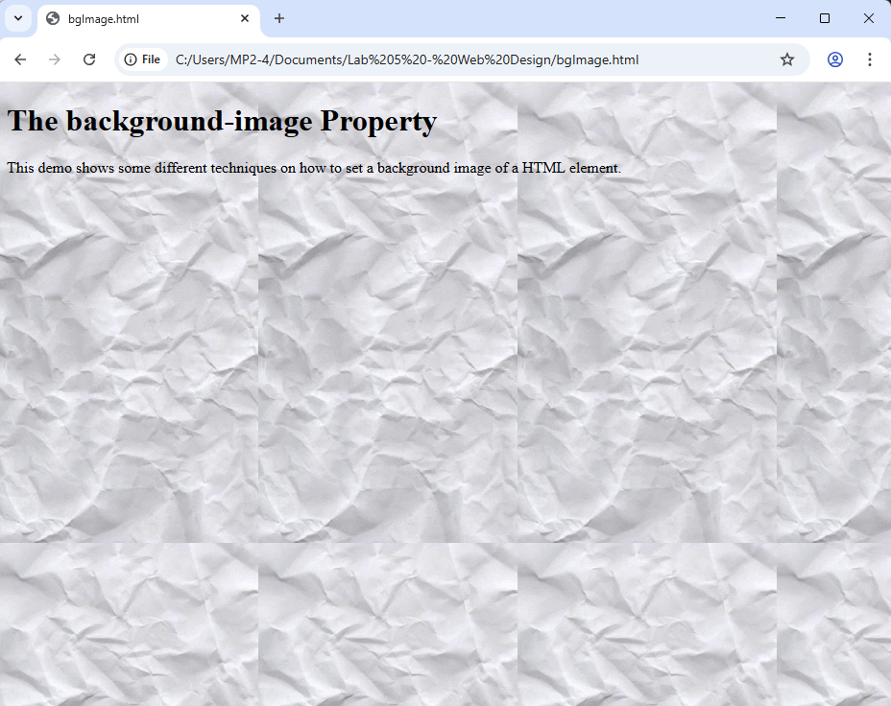
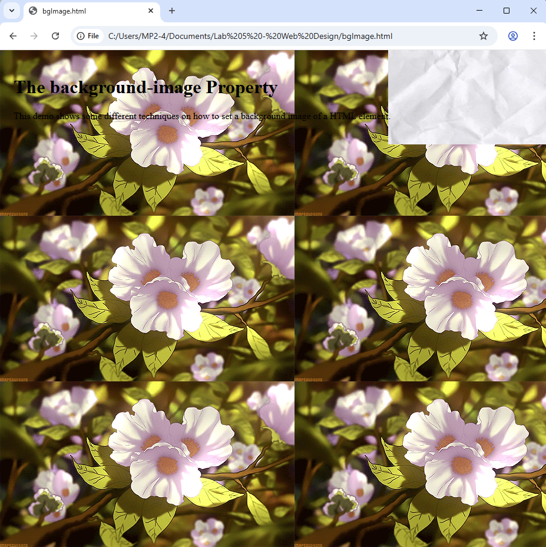
5.8 CSS Table
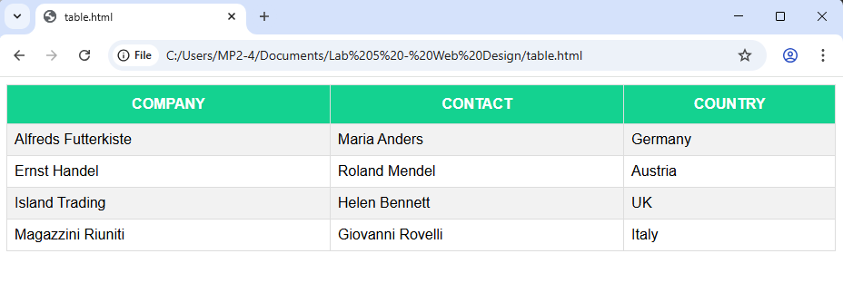

5.9 CSS Navigation Bar
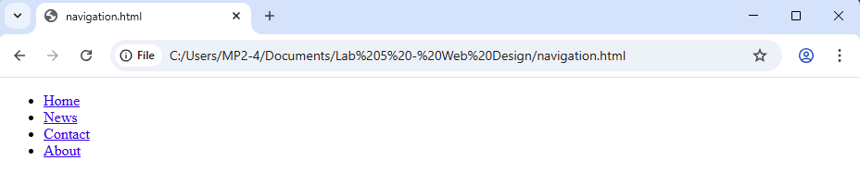
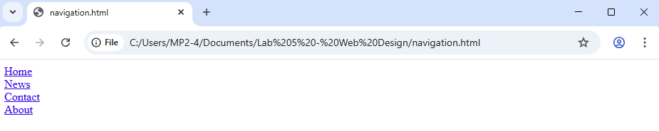
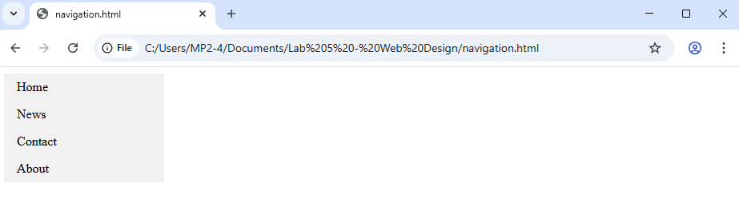
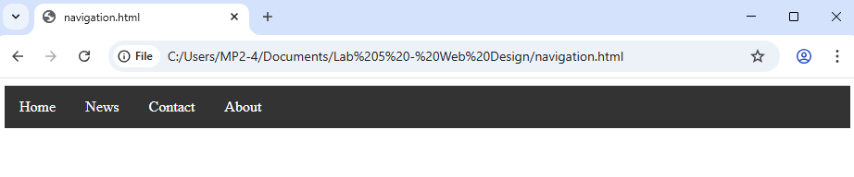

Lab Exercises
HTML Code:
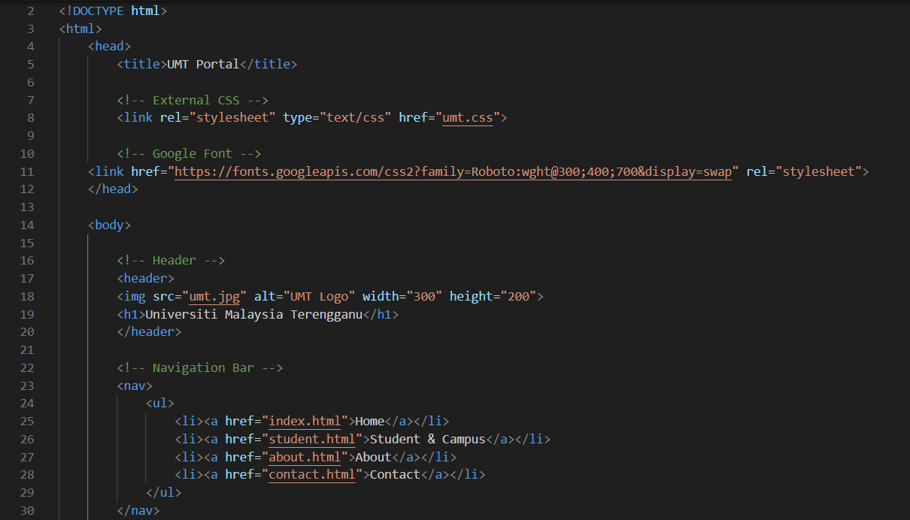
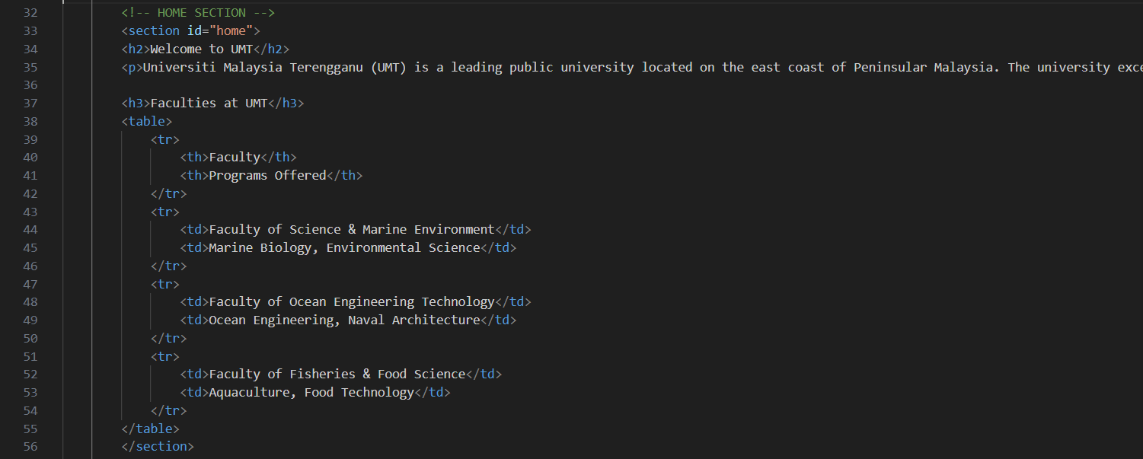
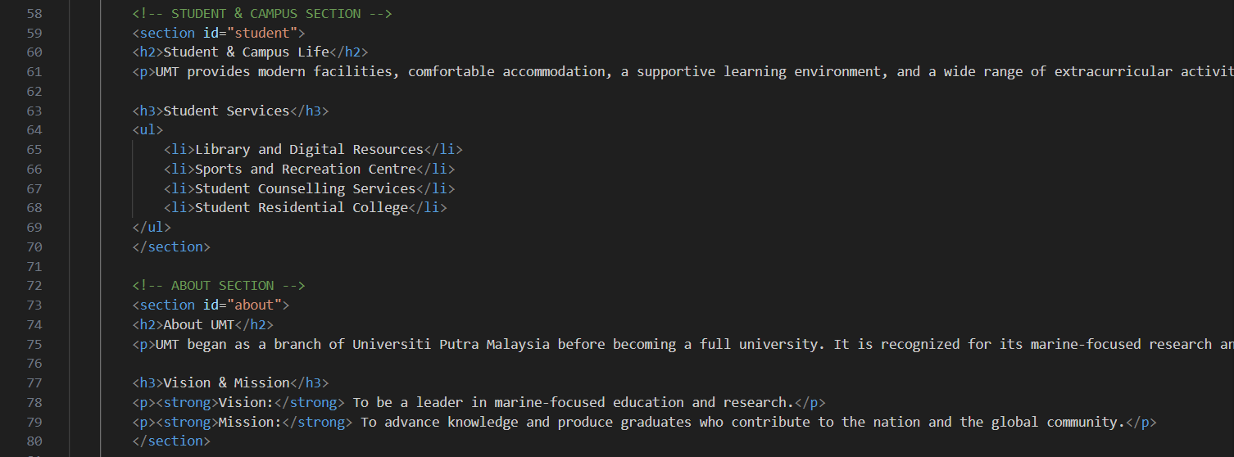

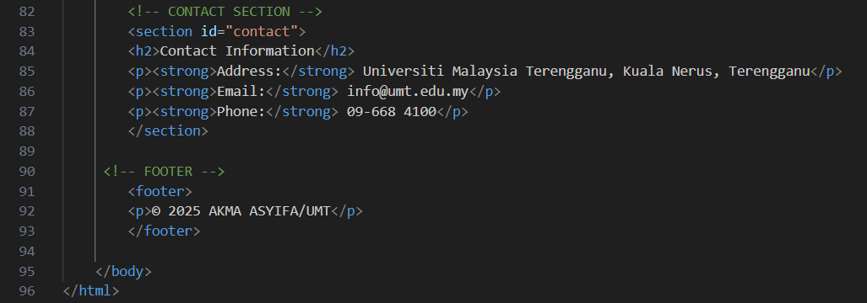

CSS File
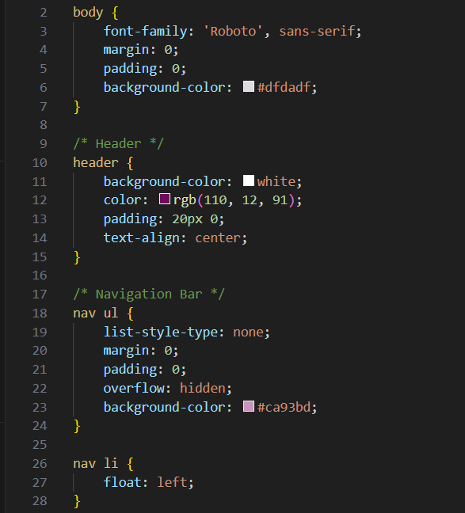
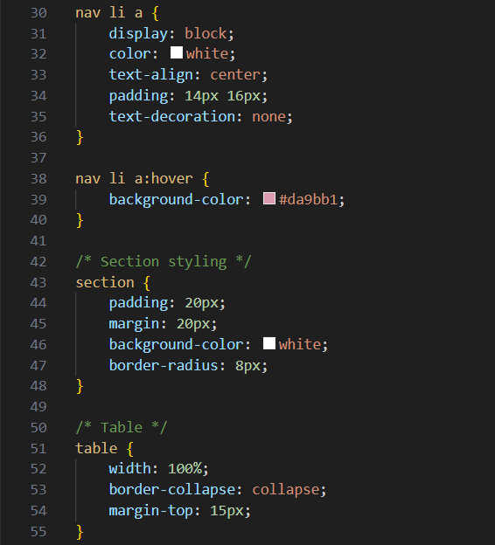
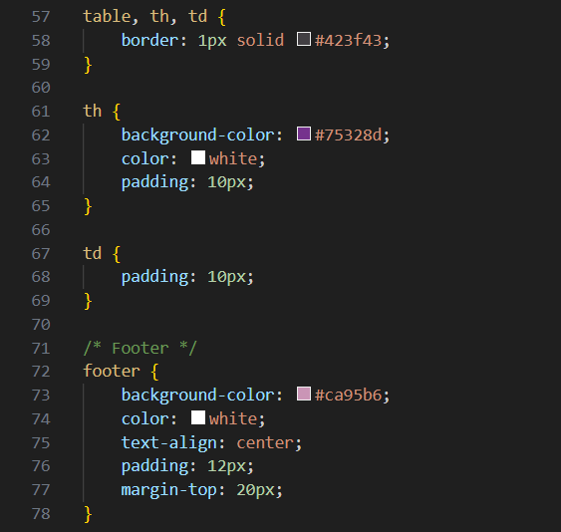

Result:
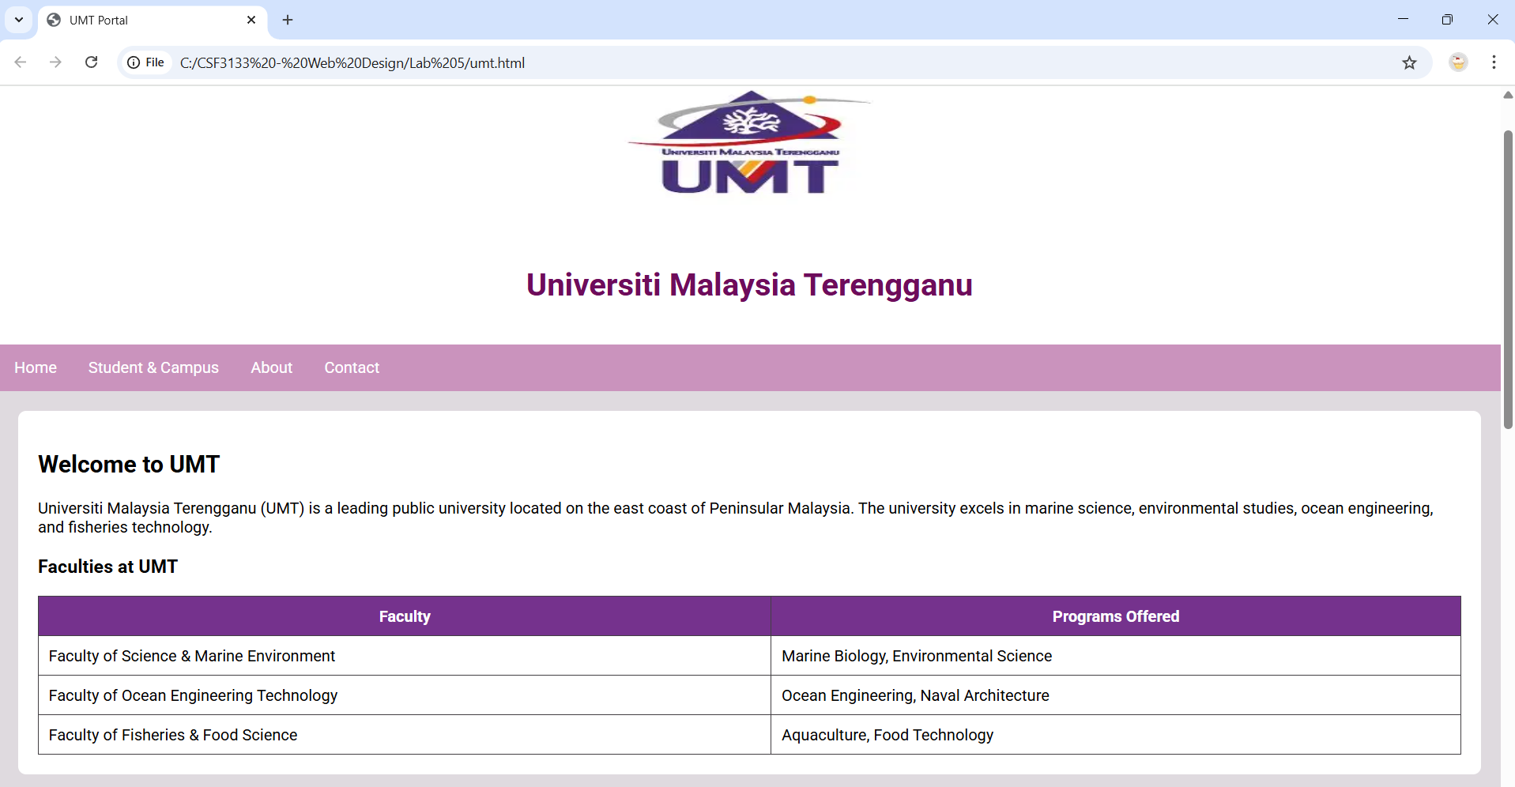
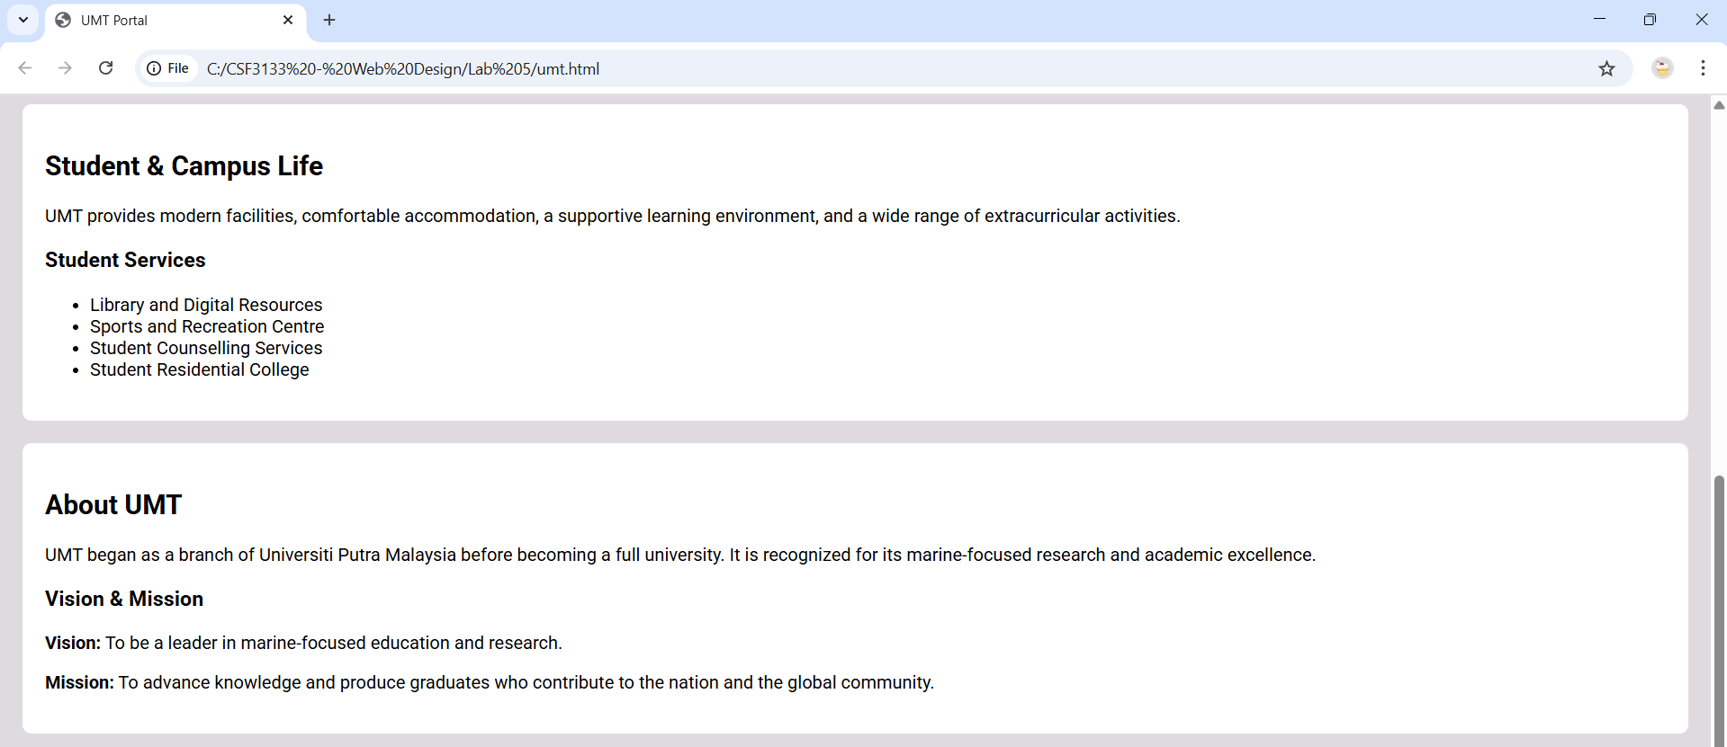



Home.html
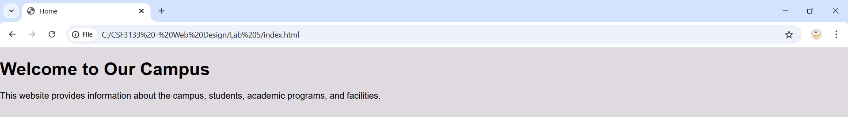
Student.html
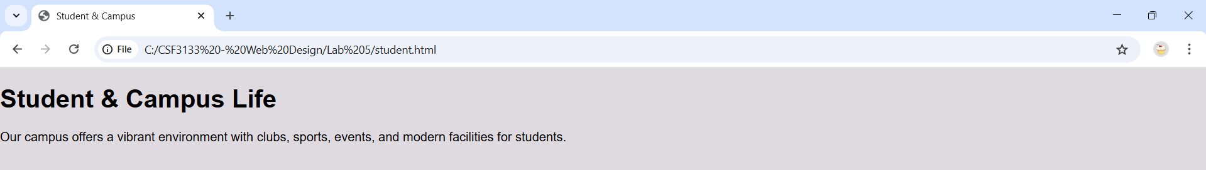
About.html
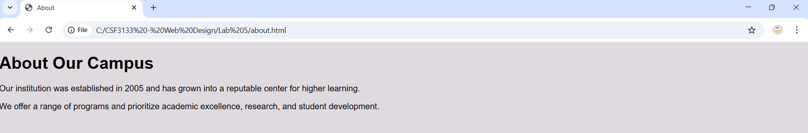
Contact.html
